ESD Floor Tile Installation Guidelines
BEFORE YOU START
Heat Expansion  Tiles can expand and contract with changes in temperature. Areas of tile that are exposed to a heat source* may expand causing tiles to lift. Please contact us for further advice regarding ESD tiles and heat expansion.  *Heat sources include but not limited to: Direct sunlight (for example south facing shutters), ovens, furnaces, catalytic converters.  Heavy Trucks and/or Tight Turning Circles  Heavy vehicles are rarely used in ESD areas, but if you do plan to use them please read the following information:  Some vehicle designs present problems for ESD tiles for example heavy trucks with small wheels or electric trucks with a battery located over the drive wheel. We strongly advise you to test the tiles with these types of vehicles or contact us if you have any concerns.  Important - If the existing floor/ substrate has already been grounded it may be necessary to lay an insulative barrier under the tiles. If in doubt, please contact us for further advice. | Surface Marks & ESD Fibres  The method of manufacture may result in a surface mark being visible on the tile at the injection moulding point (centre) and around the edge of the tile.  Please check the tiles before installation. If any markings are unacceptable, do not continue with installation as we will not accept responsibility for replacing or refunding the cost of any goods after 10m² or more have been installed.  ESD tiles contain steel fibres that may be visible on the surface of the tile.  The fibres cause our ESD tiles to set slightly larger than the standard ESD tile range, and therefore you cannot connect ESD tiles to standard ESD tiles.  Staining From Rubber Tyres  It is possible for tyres and wheels to stain the ESD tiles. This is caused by a chemical reaction between the anti- oxidant used in some rubbers and the plasticizer used in vinyl. Please contact us for further information.

PRODUCTS REQUIRED
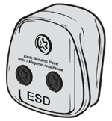
Earth Bonding Plug

Conductive Grounding Tape

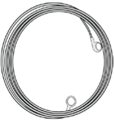
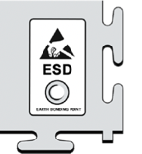

Grounding Cord
(1 Megohm Resistor)

ESD Tile with Grounding Stud

TOOLS REQUIRED
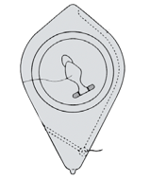
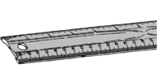
Chalk Line
(optional)
Metal 1m Ruler

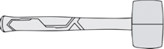

PREPARATION
Allow tiles to acclimatise in the room for 24 hours. The minimum installation temperature is 15ºc. If time is short, we recommend you split the tiles into smaller stacks (as seen in step 2) to speed up acclimatisation.  Please Note: We are unable to honour our warranty terms for installations that have taken place at temperatures below 15ºc.  If installation has to take place at a temperature below 15ºc, ensure the tiles acclimatise to the ambient temperature of the room before starting. Leave a larger expansion gap (than the recommended 5mm) between the tiles and any fixed point.  15 °c | Step 1: Sweep or vacuum the floor to remove any loose impediments. Remove any high points in the floor and fill any holes with a suitable floor repair compound.  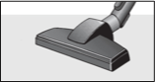  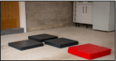  Step 2: Split the pallet into several stacks and place them around the area. They will acclimatise quicker, and will be easier to access during installation.
Rubber Mallet

CUTTING TOOLS (Choice)
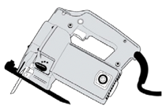
Jigsaw/ Bandsaw
Medium Blade
Concave Blade
(Utility Knife)

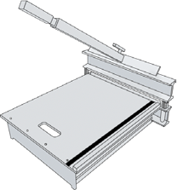

Guillotine
Available for Hire

STARTING OUT
Step 1: It’s extremely important  that tiles are kept square during installation. Every room has a different starting point. If you can, identify a straight wall or edge to work from. Snap a straight chalk or laser line 1-1.5m away from the wall.  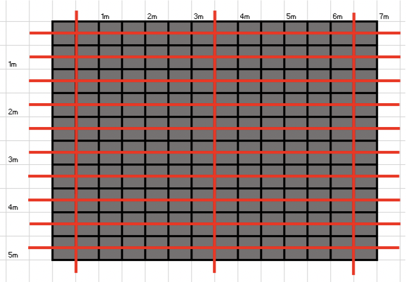  Step 2: Referring to the diagram below, lay the grounding tape as shown by the red lines. The tape must be laid every 500mm in one direction and should run under the centre of the tiles. The tape should also be laid vertically at 3m intervals. Every tile should touch the grounding tape. | Step 3: Begin fitting the tiles together creating one row of ESD tiles against the straight line. Adjust the position of the row carefully along the line considering the cuts to be made on either side.  Step 4: Add two more rows and shuffle the tiles ensuring they are as straight as possible and flush against the chalk/laser line.  Step 5: Continue to add tiles forming a pyramid (Refer to the numbering system above). | 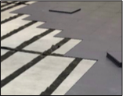  Step 6: Continue to build the pyramid adding one full size tile to the end of each row until the room is covered.  When you can no longer lay any more full sized tiles, cut the remaining tiles to fit using our cutting instructions below.  Step 7: Fit the grounding tiles near the edge of the room and connect the grounding cord and plug to the socket. A grounding tile should be installed every 60-80m².

CUTTING TILES
To make a cut, turn a tile over and place it on top of an installed tile. Push it against the wall or object as shown below.  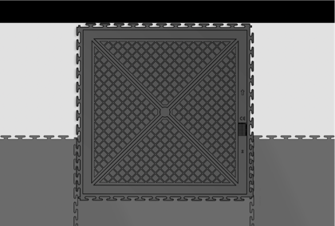 | 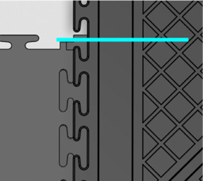  Every tile has a small square marker  in each corner. Using the edge of this marker as a guide, mark the tile you are cutting with a pen. Do the same on both sides. | Join the two marks together with a metal ruler to create a cutting line. Cut the tile using your preferred method. When the tile is flipped, it should fit leaving a 5mm gap between the edge of the tile and the wall.  Continue until you have completed the remaining cuts.  We recommend you finish the edges with caulk and/or skirting boards.
UTTING TIES
FOR THE PERFECT ESD FINISH
+ Leave an expansion gap (minimum of 5mm) between the tiles and any fixed point.
+ We highly recommend that you clean the floor immediately after installation to ensure optimum ESD performance.
+ Don’t force tiles together - if they don’t fit together easily, something is wrong.
+ Undercut wooden doorjambs and slip the tiles underneath.
+ Use ramps to create safe transitions into the room.
+ Glue the tiles if they are exposed to direct sunlight (refer to Page 1 - Heat Expansion).

Cleaning & Maintenance
Vacuum or sweep your floor regularly. Use a rotary scrubber dryer or flat head mop.
Contact us for more information on cleaning adhesives.

